Title: Assessment, credentialling and recognition in the digital era: Recent developments in a fertile field ---Sandra K Milligan, Gregor E Kennedy and David Israel

Generic or soft skills or competencies – ralely assessed, the quality of learning outcomes in these areas is not well guaranteed.
development of specific competencies in areas of practical expertise or professional skill/continuing and professional education
development of metacognitive skills or learning skills to equip individuals for career-long learning.

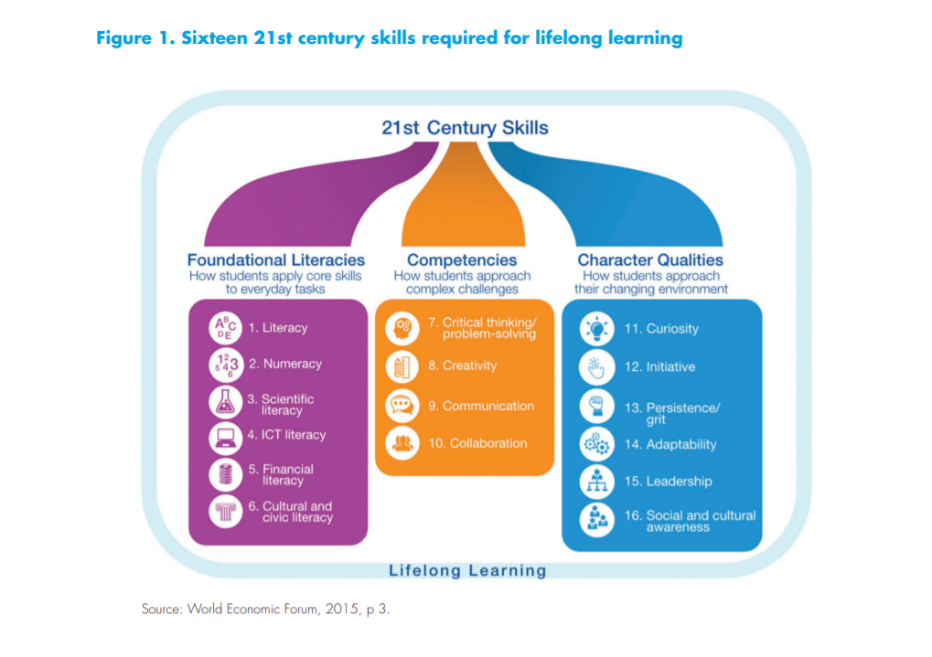
Expected learning outcomes are stated as specific competencies, and the statements describe in some detail what learners are expected to learn, what they will be able to do and to what standard.

Expected learning outcomes:
(a) generic graduate outcomes in the ‘soft areas’; and/or
(b) specific professional skills; and/or
(c) metacognitive learning skills

Micro-credential ecosystem

Level:
nano-degrees’, ‘micro-master credentials’, ‘certificates’, and ‘badges’
‘ratings’ or ‘licences’ or ‘endorsements’, or ‘memberships’.

Badge:
Badge: digital graphical file
Badge issuer
badge earner
badge graphic
Badge metadata
Consumers/stakeholders: to whom demonstrate the badge
Endorser: who recognize the badge

Obstacles:
cost, time, complexity of the policy and legal environment, privacy issues, ownership of the badge or micro-credential, verification and integrity issues,
student concerns about credibility, faculty acceptance, and students’ attachment to conventional, paper-based processes.

Fragment learning
micro-credentials might fragment learning.
Joined together to form other larger credentials

e.g. MIT MSCM supports a candidate to earn an edX certificate for each of the MOOCs they study. Clusters of three or four of these ‘stack’ to form edX x-series certificates

Assessment:
Digital tools for supporting assessment, credentialling, and recognition
Portfolios:
digital portfolio technologies---digital evidence
business plans, programming or test products, videos of people teaching or consulting with patients, and fashion or design portfolios
Peer assessment:
Automated assessment:
x-box assessment available in edX MOOCs,
Intelligent essay marking and natural language processing:
Big data analytics
data generated by learning platforms (log stream data, and data generated by tools such as surveys, eye-gaze monitors, facial recognition, and so on)

